Course project: An AI-powered customer support assistant for an online store.

1. Project goal
Build a customer support agent that can answer questions about online store policies and customer-specific order/account data by combining:
- RAG (Retrieval-Augmented Generation) - semantic search over policy documents.
- LLM with tool use - LLM decides when to retrieve policies and when to query the database.
- MCP tools - a Model Context Protocol server exposing read/write access to the SQLite store database.
- Two interfaces - a command-line chat and a browser-based chat with live “thinking” steps.
- Agentic loop - The agent receives a goal and decides on it’s own what is the next step – use on of the available tools or respond to the customer.
- Long conversations – the agent should have a memory of the current conversation.
The agent should handle customer support questions like “Can I return my last order?”, “Where is my shipment?”, and “Why was my payment rejected?” by retrieving the right policy text and querying the right database tables.
The agent should also be able to perform operations on behalf of the user. In this case it will be able to open a ticket for the user by adding it to the support_tickets table.
What you receive (starter materials):
- Policy knowledge base (dataset_design/01_knowledge_base_documents.md) - 21 store policy documents
- Database schema design (dataset_design/02_sql_schema_definition.md)
- Sample data specification (dataset_design/03_generated_dataset_samples.md)
- Example support scenarios for testing (dataset_design/05_example_support_scenarios.md)
- Database initialization script (database/init_db.py) - creates database/store.db with sample data
What you must build: All application code: RAG indexing and retrieval, MCP server, agent logic, CLI, and web UI.

2. High-level architecture

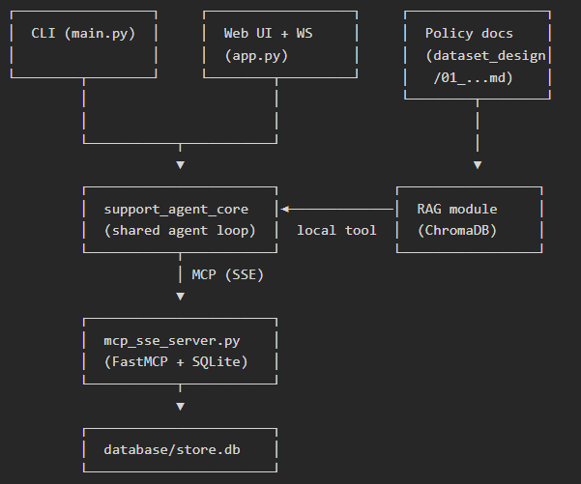

3. General Requirement:
- The core of the agent is an agentic loop that uses LLM, tools and memory.
- The agent should be able to handle multiple users simultaneously. All LLM and API calls should be asynchronous. Use async and await where required.
- LLM – use Anthropic Haiku 4.5 or model with similar capabilities.
- Memory – the agent will keep the history of the conversation, up to 20 messages.
- MCP – The connection to the database will be through MCP server.
- RAG – The knowledge base (policies) will be kept in a RAG (Chroma DB) and exposed as a tool for the agent.
- The agent will have a command line and a web interface.
- Web UI update with websocket to keep smooth web experience.
- The agent should help the user to create a ticket if needed (insert a row in the tickets table).
- Guardrails – the agent authenticate the user and should not allow to get unsafe information like other users information and table information.

- Knowledge base requirements:

- The knowledge base will contain all the relevant policies.
- Use Chroma DB on local server and BERT all-MiniLM-L6-v2 model.
- No chunking is required as we want to give the agent the full policy.
- Return 5 policies per query, should be easily configurable.

5. Database requirements:
- Use SQLite on local server.
- Use init_db.py to create the tables and content.
- The DB should expose read and write operation. The write operations should be used to create a ticket in the support_tickets table.
- You can use SQLite Viewer Extension on Cursor to view structure and content.

6. Web UI requirements:
- The Web UI should be a simple chat – client insert a prompt, the agent answers.
- There should also be an option to see the thinking process for debug purposes. The thinking process are the intermediate steps of the agent before inserting the final results. Including reasoning and tool use.
- See example of UI below.
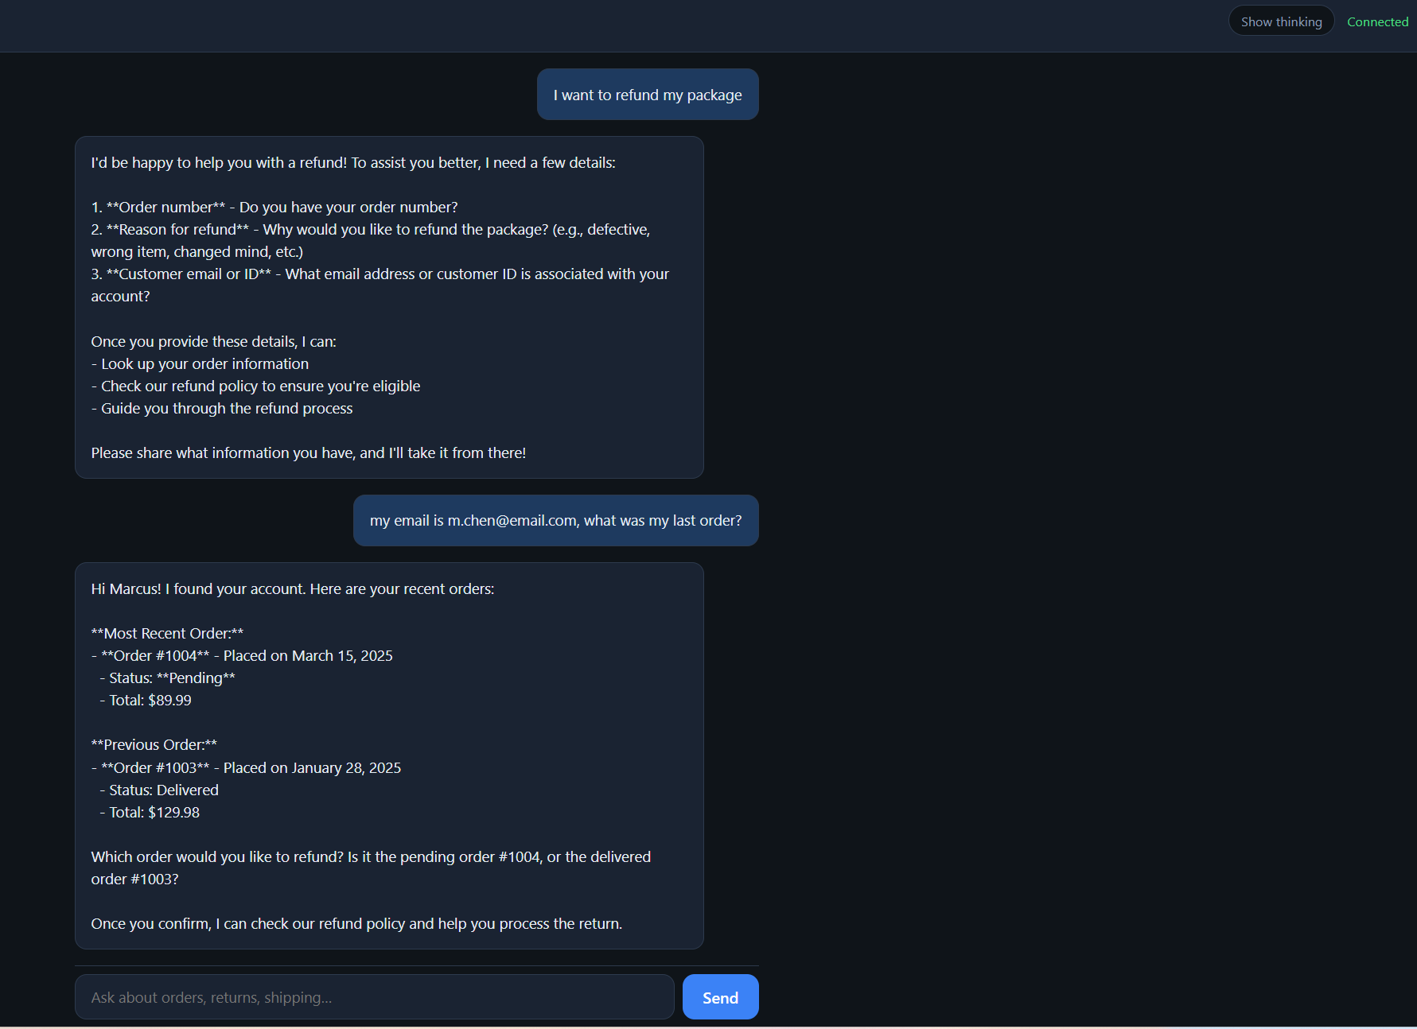

7. Deployment:
- Should be able to deploy on an AWS EC2 server.
- Deploy on an EC2 server and make sure you can access from your own PC.
- Remember: Shutdown the server when not being used. To avoid excessive payments.

8. Stretch goals:
- Wrap the agent in a docker container.
- Separate the web to a new process so the web will be the client and the agent will be the server. You still need to use Websocket communication between the agent and the client.
- Have an option for fallback model using LiteLLM. For example, use Haiku 4.5 as main model, but if the request to Anthropic is not successful, fallback to Gemini 3.5 Flash.
Implementation plan:

Phase1:
Build RAG solution for knowledge base plan. The agent should know how to respond to questions about the company policies.
CLI interface.

Phase 2:
The agent should be able to answer question from the database through MCP server.
The agent should be able to authenticate the user through it’s email and make sure to answer questions only for the relevant user.

Phase 3:
Build UI interface.
Support multiple sessions (users) at the same time.

Phase 4:
Deploy the agent on an AWS EC2 server.

